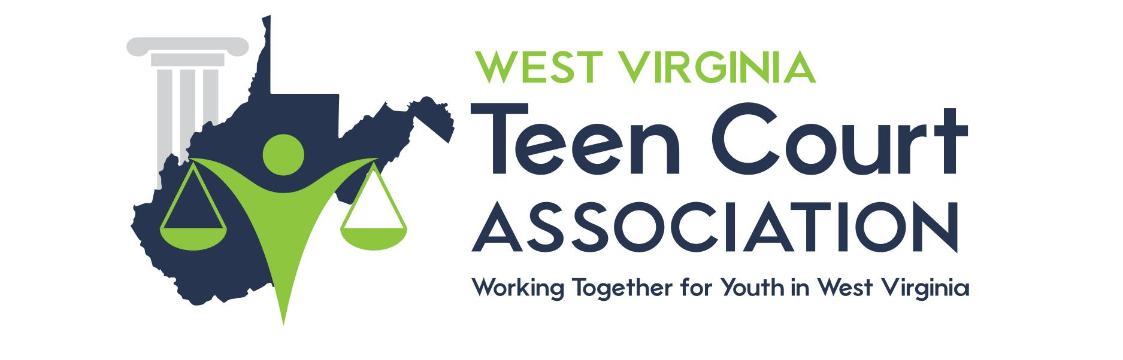

MEDIA WAIVER FORM

Media Waiver of Confidentiality and Memorandum of Understanding

I ________________________________ agree to speak with, be photographed by, and be videotaped by the media and have my name used and agree to have my face shown on television or videotape or the Internet for the educational and court purposes that WV Teen Court will portray.

Photographs will be used on the WV Teen Court website at https://wvteencourt.org/. If photographs are to be used on any site other than https://wvteencourt.org/, a separate waiver must be filled out and signed.

Additionally, you may elect to have your photograph used on the Internet, but not have your name used by initialing here: ____________

Juvenile Signature______________________________________________

Date ________________

Parent/Guardian Signature*_____________________________________
*Parental signature is required for juveniles under the age of 18.
Date ________________

